DATA FLOW DIAGRAMS & USER STORIES
Team ID: SWTID-2026-3491 | Date: 1 October 2026
Project: Import Data using Transform Maps (Spreadsheet)
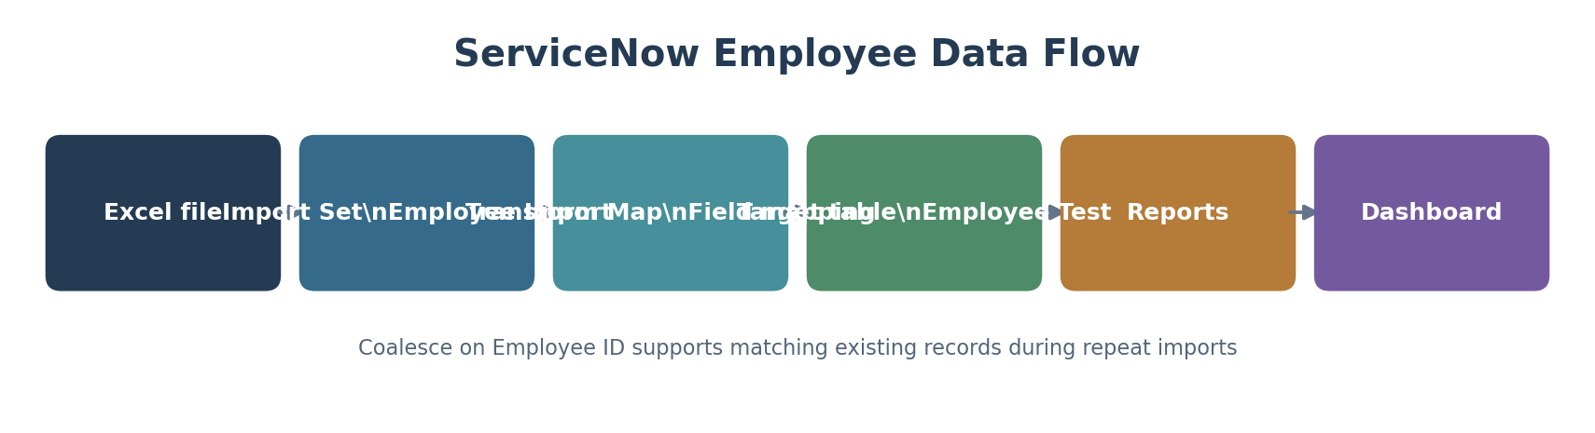
Data flow description
Flow | Description
Source → staging | Employee spreadsheet is uploaded through Load Data into Employee Import (Import Set table).
Staging → transform | Sample Spreadsheet Import maps source fields to Employee Test target fields.
Transform → target | Transform execution creates target records; Coalesce on Employee ID matches existing records for updates.
Target → reporting | Employee Test supplies Employees by Department, Employees by Location and Employee List Report; these are added to Employee Analytics Dashboards.
User stories
As a… | I want to… | So that… | Acceptance criteria
ServiceNow beginner | load an employee spreadsheet into an Import Set | I can stage bulk records | Employee Import table is created and uploaded rows show completed/success state.
Administrator | map source fields to Employee Test | the data lands in the intended fields | Employee ID, Employee Name, Email, Department and Location are mapped and transform completes.
Data steward | use Employee ID as Coalesce | repeat imports update existing employees instead of duplicating them | Existing IDs update; new IDs insert; identical repeat file can be reviewed in transform history.
Reviewer | create reports and a dashboard | I can inspect employee data by department, location and list | Three reports are saved and added to Employee Analytics Dashboards.

